 | UNESCO Global Geopark name, country  1 page summary prior-to-revalidation

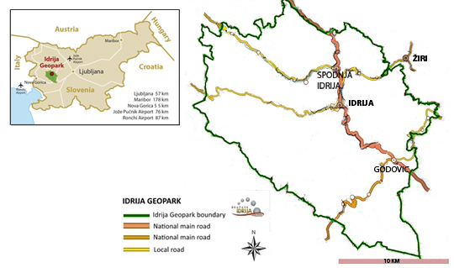

Contact person (name, position, e-mail): | Surface area in km²:
Website: | Population:
Year of acceptance as Global Geopark (GGN): | Previous revalidation(s):

Summary of geology including the defining sites of international significance:

